
Grasmere Academy

SEND Information Report
2026-2027
Learn, Flourish, Achieve

Every child belongs.
We want every child to feel safe, included and valued. Children learn and develop in different ways. We work with families to understand each child and help them make progress, build confidence and take part in school life.

A guide for parents and carers

Welcome to our SEND Information Report
At Grasmere Academy, we believe that every child has the right to learn, belong and achieve. We know that children have different strengths, interests and needs, and that some children need extra support or adjustments to help them access learning and school life.
We do not expect children to fit one way of learning. We aim to adapt our teaching, environment and support so that children can take part, develop independence and make progress.
This report explains how we identify and support children with special educational needs and disabilities (SEND), how we work with parents and carers, and where families can find further advice.

Please talk to us.
You do not need to have a diagnosis or know exactly what support your child needs before contacting school. If you have a concern, we will listen and discuss the next steps with you.

Contents
- 1. What does SEND mean?
- 2. The four broad areas of need
- 3. Who can I talk to?
- 4. How do we identify needs?
- 5. How is support planned and reviewed?
- 6. What support might my child receive?
- 7. Working with parents, carers and pupils
- 8. Working with other professionals
- 9. Communicate at Grasmere
- 10. Inclusion, accessibility and school activities
- 11. Transitions between settings
- 12. If you are worried or unhappy
- 13. Useful contacts and glossary

1. What does SEND mean?
SEND stands for Special Educational Needs and Disabilities. A child may have special educational needs (SEN) if they have a learning difficulty or disability that means they need special educational provision to be made for them.
This may mean that a child finds learning more difficult than other children of a similar age, or that a disability makes it harder for them to access the education and opportunities usually available in school.
Children's needs can be temporary or ongoing, and children may need support in one or several areas. A diagnosis is not required before school can respond to an identified need.
A child is more than their needs.
We look at each child's strengths, interests, views and aspirations as well as the things they find difficult. Our aim is to understand what helps them learn, communicate, feel settled and participate.

2. The four broad areas of need
The SEND Code of Practice describes four broad areas of need. These help us organise information and plan support. They are not labels, and a child may have needs in more than one area.
AREA OF NEED | WHAT THIS MIGHT LOOK LIKE / HOW WE MAY HELP
Cognition and learning | A child may need extra help with reading, writing, maths, remembering information, processing instructions or learning new skills. Support may include adapted teaching, additional practice, visual resources, targeted small-group work and strategies to build independence.
Communication and interaction | A child may find it difficult to understand language, express thoughts and needs, interact with others or manage social situations. This can include autistic children and children with speech, language and communication needs. Support may include visual timetables, communication aids, clear language, structured routines and support with interaction.
Social, emotional and mental health | A child may experience anxiety, find emotions difficult to manage, have relationship difficulties or face other barriers to feeling settled and ready to learn. Support may include trusted adults, predictable routines, emotional-regulation strategies, pastoral support and appropriate interventions.
Sensory and/or physical needs | A child may have hearing or visual needs, a physical disability, medical needs or differences in how they respond to sound, touch, movement or light. Support may include reasonable adjustments, accessible resources, suitable equipment, sensory strategies and advice from relevant professionals.

3. Who can I talk to?
Your child's class teacher is usually the best first point of contact if you have questions about learning, development or wellbeing. You can also ask to speak to the SENDCo.
The SENDCo coordinates SEND provision across the school. This includes supporting staff, helping identify needs, discussing strategies and working with families and other professionals.
At Grasmere Academy, the SENDCo is Helen Winship. Appointments can be arranged by contacting the school office by telephone or in person.
You can also raise a concern with the Deputy Headteacher or Headteacher if appropriate.

You do not have to wait for a parents' evening.
If you are worried about your child, please contact us. We will arrange a suitable time to listen and discuss your concerns.

4. How do we identify needs?
Children develop at different rates. Sometimes a child may need additional support with learning, communication, behaviour, relationships, physical access or emotional wellbeing. We use a range of information to help us understand what is happening.
- Conversations with parents and carers about what they notice at home.
- Observations of the child in lessons, play and other parts of the school day.
- Assessment information and the child's progress over time.
- The child's views, preferences and experiences, using communication methods that work for them.
- Information from staff who know the child and, where appropriate, advice from other professionals.
If we have a concern, we will aim to discuss it with you. We will consider the child's strengths and needs, the support already in place and what else might help. We will not assume that every difficulty is caused by SEND; we will consider the whole picture.

What happens next?
- Talk together: we listen to your concerns and share what we have noticed in school.
- Understand the need: we look at the information available and identify barriers to learning or participation.
- Agree a plan: where appropriate, we agree strategies, support and what progress we hope to see.
- Put support in place: staff use the agreed approaches and keep track of how the child responds.
- Review: we discuss progress with you and decide whether support should continue or change.

5. How is support planned and reviewed?
For children receiving SEN Support, we use the Assess–Plan–Do–Review approach. This is a cycle: we learn about the child's needs, plan support, put it into practice and review how well it is working.
ASSESS — understand | We gather information about your child's strengths, needs, progress and any barriers they face.
PLAN — agree | We decide what support or adjustments may help, what we hope to achieve and how progress will be checked. Parent and pupil views should inform the plan.
DO — put into practice | Teachers and other staff use the agreed strategies, resources or interventions.
REVIEW — check and adapt | We look at what has changed, listen to your views and decide whether to continue, adapt or introduce different support.

Support and targets are reviewed regularly. The school's report describes termly reviews for SEN Support. Education, Health and Care Plans (EHCPs) are reviewed at least annually, in line with statutory requirements. The school also plans transition reviews for pupils moving to secondary school.

What is the difference between SEN Support and an EHCP?

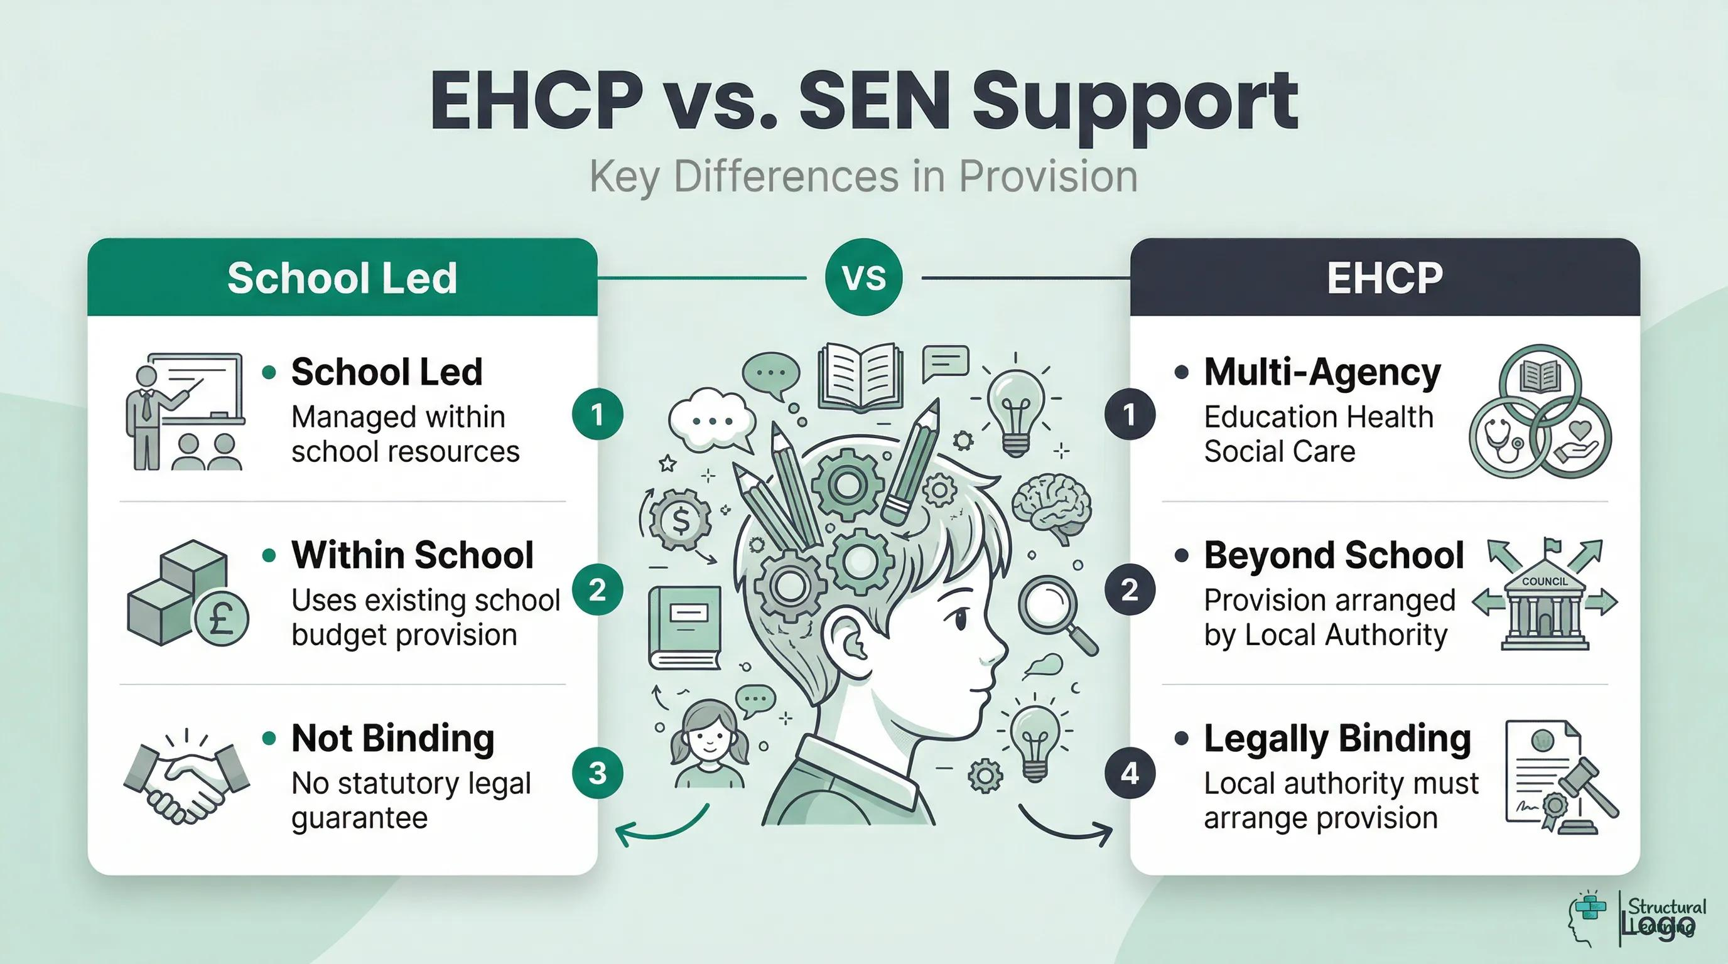

SEN Support is additional or different help provided by the school to meet a child's identified needs. A child does not need an EHCP to receive SEN Support.
An Education, Health and Care Plan (EHCP) is a legal plan for a child or young person whose needs meet the criteria for an Education, Health and Care needs assessment and whose support requires a statutory plan. Decisions about an assessment or plan follow the Local Authority's process. The school can discuss concerns, share evidence and work with families as appropriate.

How are resources and support decided?
School leaders and the SENDCo discuss the support and resources needed to help pupils make progress. Depending on the child's needs, this may include additional adult support, specialist advice, adapted resources, software or equipment. Support is considered in relation to the child's identified needs and reviewed as we learn what is helpful.

6. What support might my child receive?
Support will depend on the individual child. It may be provided in the classroom, in a small group, through a targeted intervention or through adjustments to the environment or school day. Examples include:
- High-quality, inclusive teaching with tasks and resources adapted where needed.
- Visual timetables, now-and-next boards, clear instructions and communication supports.
- Targeted help with literacy, numeracy, speech, language, communication or other identified skills.
- Support to develop independence, friendships and social communication.
- Strategies to support emotional wellbeing, reduce anxiety and help children feel ready to learn.
- Access to quieter or low-distraction spaces, sensory resources or movement opportunities where appropriate.
- Advice from specialist professionals, where this is available and appropriate.
- Reasonable adjustments to help children access PE, clubs, trips, residential visits and other school activities.
We aim to keep parents informed when a targeted intervention is introduced and to explain its purpose. Please ask your child's teacher or the SENDCo if you would like to know more about a particular strategy or intervention.

7. Working with parents, carers and pupils
Parents and carers know their children well. Your views help us understand what your child enjoys, what they find difficult, what works at home and what is important to them. We want families to feel listened to and involved in decisions.
We gather views in different ways, including conversations, questionnaires, parents' evenings, support-plan reviews and annual reviews. We also seek the child's views in ways that are appropriate to their age, communication and understanding.
We share progress through discussions, parents' evenings, written reports and review meetings as appropriate. Parents' evenings are held in the Autumn and Spring terms, with written reports in the Summer term.

Working together makes a difference.
Please tell us if something is working well at home, if circumstances change, or if you feel the support is not meeting your child's needs. We can then consider the next steps together.

8. Working with other professionals
Sometimes advice from a specialist can help us understand a child's needs and identify strategies. Depending on the child's needs and the services available, professionals who may work with or advise school and families include:
- Speech and language therapists and the Language and Communication Team.
- Occupational therapists and physiotherapists.
- Educational psychologists.
- Dyslexia and dyscalculia services.
- School nursing and relevant health professionals.
- Mental health services and behaviour support services.
- Early Years Portage and outreach services.
- Children's Services, Public Health and Family Gateway.
- Early Years Inclusion Team

Not every child will need every service. Involvement depends on the child's needs, professional advice, service criteria and availability. We will discuss relevant involvement with parents and carers and work together where appropriate.

9. Communicate at Grasmere
Grasmere Academy has a specialist Language and Communication Unit called Communicate at Grasmere. The unit supports children with significant speech, language and communication needs and works alongside the school's wider provision.
We recognise that children communicate in different ways and have individual strengths, interests and support needs. The aim is to support communication, learning, relationships, confidence and independence in an environment that meets each child's needs.
Support is tailored to the individual child and may include structured routines, visual communication strategies, adapted learning activities and advice from relevant professionals.
Places in the specialist unit are agreed by the Local Authority through the EHCP process. Families who would like to understand more about the unit or the placement process can contact the SENDCo.

10. Inclusion, accessibility and school activities
We want pupils with SEND to take part in the life of the school. We consider what adjustments may be needed so that children can access learning and activities, including PE, after-school clubs, trips and residential visits.
Risk assessments and appropriate arrangements are made where needed to support pupils' safety and participation. We are happy to discuss a child's individual access requirements with their family.
Please see the school's Accessibility Plan and relevant policies on the school website for further information.

Staff knowledge and training
We believe every teacher is a teacher of every child. Staff are supported to develop their understanding of SEND and to use inclusive teaching approaches. The SENDCo provides advice and guidance to staff and is available to consult with parents and carers.
The school has staff with additional experience or training in areas including mental health, Thrive approaches, Elklan, reading interventions, speech and language support and dyslexia interventions. Staff training and specialist expertise may develop over time.

Supporting families
Our safeguarding team is available to support pupils and families. We also work with families to help them understand strategies that may support their child's learning and development beyond school.

11. Transitions between settings
Moving to a new class, school or stage of education can feel like a big change. We plan transitions carefully and share relevant information with the next setting, in line with appropriate information-sharing arrangements.
- Home visits are arranged for children joining the Foundation Stage, as described in our current arrangements.
- Staff liaise with health professionals and previous nursery settings where appropriate.
- Transition visits and review meetings may be arranged for pupils with SEND, involving parents or carers and staff from both settings.
- Additional visits or support may be arranged for pupils who may find change difficult.
- For pupils moving to secondary school, the SENDCo may support transition planning and liaise with the receiving school.
If you think your child will need extra help with a transition, please speak to the class teacher or SENDCo as early as possible so that we can discuss what may be helpful.

12. If you are worried or unhappy
If you have concerns about your child's needs, progress or the support being provided, please contact the class teacher and/or SENDCo first. We will aim to listen carefully, understand the concern and work with you to find a way forward.
If you feel that your concern has not been resolved, you can follow the school's formal complaints procedure. The relevant policy is available on the school website.
Families can also seek independent advice and support from SENDIASS (Special Educational Needs and Disability Information, Advice and Support Service).

13. Useful contacts
SENDCo | Helen Winship
Telephone | 0191 222 0259
Email | helen.winship@grasmereacademy.org.uk send@grasmereacademy.org.uk
Website | www.grasmereacademy.org.uk
SEND Governor | David Baldwin
SENDIASS (North Tyneside) | 0191 643 8313 or 0191 643 8317
SENDIASS email | sendiass@northtyneside.gov.uk
Local Offer | North Tyneside Local Offer: please use the current link on the Local Authority website.

Useful documents
The following documents provide more detail about the school's arrangements and are available through the school website:
- Special Educational Needs and Disability (SEND) Policy.
- Accessibility Plan.
- Behaviour and Anti-Bullying Policies.
- Complaints Procedure.

Glossary
SEND | Special Educational Needs and Disabilities.
SEN | Special Educational Needs.
SENDCo | Special Educational Needs and Disabilities Coordinator.
SEN Support | Additional or different support provided by school to meet identified needs.
EHCP | Education, Health and Care Plan.
Assess–Plan–Do–Review | A cycle used to understand needs, plan support, put it in place and review progress.
EYFS | Early Years Foundation Stage.
Speech and language | Support relating to understanding language, expressing oneself and communication.
Local Offer | Information published by the Local Authority about services and support for children and young people with SEND and their families.
SENDIASS | Special Educational Needs and Disability Information, Advice and Support Service.

Reviewing this report
We review this SEND Information Report annually. We welcome feedback from parents and carers about whether the information is clear, useful and answers the questions families have. Please share your comments with the SENDCo.
Our commitment
We will listen to families, value each child's individuality and work together to help children learn, flourish and achieve.

